Where Real Estate Meets the Future of Wealth
Own the Future. Earn While You Sleep. Powered by AI. Backed by Real Estate.
(Join waitlist NOW)
SHREC token is Hybrid between Real Estate and Cryptocurrency
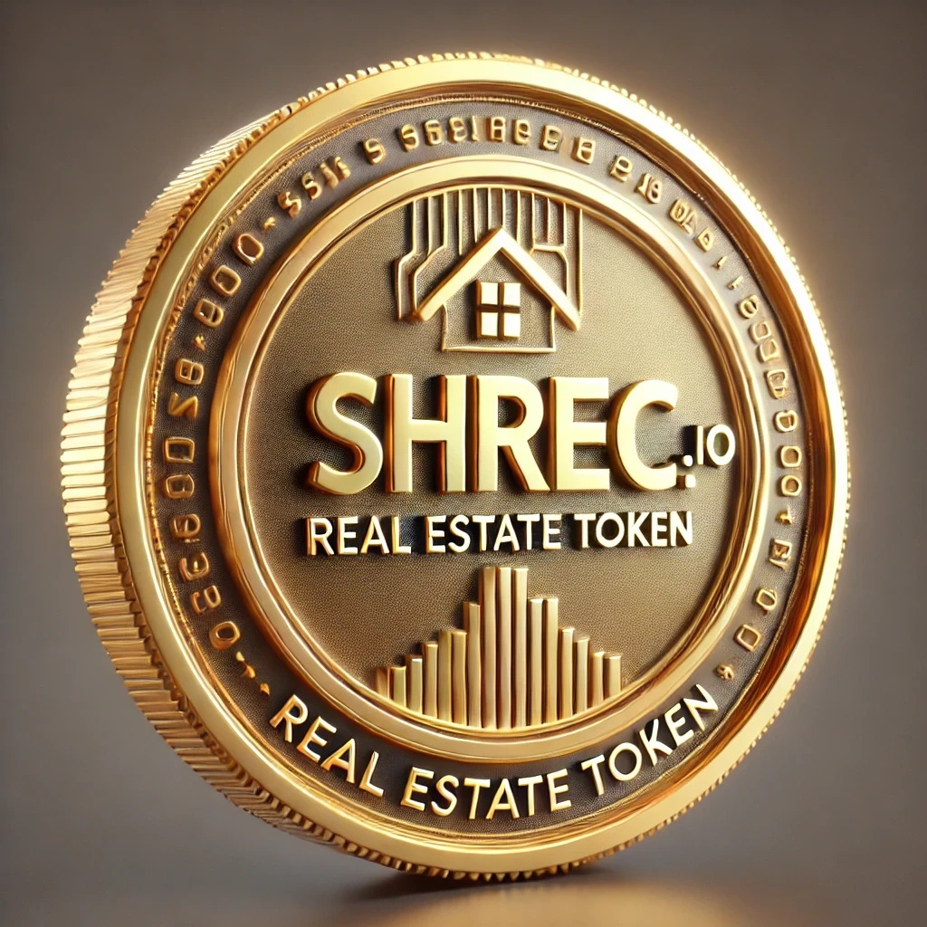
SHREC isn’t just another crypto project. It’s your ticket to financial freedom. Imagine owning a share of high-yield real estate — without the paperwork, without the stress. Just pure, automated monthly income delivered straight to your wallet. Unlike competition we offer buy back of tokens for EURO or USD.
✅ Real estate-backed
✅ Ultra-low fees with AI
✅ Full transparency
✅ Passive income from day one
🚀 Only limited spots available. Join the waitlist now or miss out forever.
(Join waitlist NOW)

Crypto-Backed Real Estate = Real Freedom
This is how the wealthy stay wealthy — by making their money work for them. With SHREC, you can do the same.
We’ve built the most efficient crypto investment fund powered by real estate and artificial intelligence. Every SHREC token gives you ownership of real-world property — and a share of the monthly rent and profits from future sales.
💸 The more tokens you hold, the bigger your slice of the pie.
🌍 Ethereum L2 = lightning-fast and cheap transactions
🔁 Need liquidity? We’ll buy back your tokens in EUR/USD based on current cash flow.
📩 Join the waitlist now — tomorrow might be too late.

Why SHREC Is a No-Brainer for Smart Investors
Start small. Think big. Earn forever.
We combine your investment (starting at just €100!) with bank financing to acquire undervalued real estate across Europe — mainly in Czechia and Serbia, with 15 more countries in sight.
🔒 100% transparent
📈 Fully audited
💥 Designed for long-term growth
🧠 AI-driven, human-tested
Want VIP treatment? With €40,000+, you unlock private deals and priority access to premium assets.
📊 Our Token System = Total Control + Real Ownership:
- 🏠 Property-backed tokens
- 📈 Value grows with appreciation & rent
- 💰 You earn every month — just by holding
👉 SHREC tokens are minted ONLY when there's real value behind them. No hype, just cash flow.

Real Estate Deals You Can’t Find Anywhere Else
We’re not just buying property — we’re taking over the market.
Thanks to our exclusive access to distressed real estate deals, we acquire properties way below market price. That means bigger margins, higher yields, and more profits in your pocket.
These deals go fast. So should you.

🚨 Launching June 1st, 2026 — But Only for the Fastest
If you’re seeing this, you’re early. And in investing, early = rich.
⏳ Fewer than [67] investor slots left
💰 Early supporters get the best price and lowest fees
🔥 Tokens backed by real cash flow from rent & property growth
🛡️ MiCA EU compliant = safe, stable, secure
Think of SHREC as your passport to financial freedom. One token at a time.
💎 Join the waitlist now before it's full. Freedom doesn’t wait.

Led by Experts. Built for Winners.
This isn’t our first rodeo. Our team blends real estate veterans, crypto pioneers, and legal & financial pros with decades of experience across Europe.
- Petr Uklein – CEO & CLO
- Richard Kraus – Finance, Legal & Ops
- Pavla Bachurová – Legal
- Roman Staroselskiy – IT and Blockchain expert
- Barbora Janáčková – Head of Real Estate
- Tomáš Kolařík – Banking and compliance
- Jonáš Melecký – Marketing Specialist
Your money is in very good hands.

FAQs
How do I buy SHREC?
Right here. Right now. Just connect your wallet or create an account. Once you invest, your tokens are matched to a real property — and you start earning. Instantly.
You can also choose to join a specific real estate project or just invest and let us do the heavy lifting. Either way: you earn.
When can I monetize my crypto?
You can sell your token to anyone (not us) anytime, this way you obtain from such a person other crypto or FIAT. After reaching a dedicated period (unique per investment, usually 24-26 months), you can sell your token back to us to obtain Euro or US dollars. If you would demant to sell to us sooner that dedicated period, deducting fee applies. Transaction fees and AML procedure apply.
⏰ Don’t let this be one of those “I wish I had” moments. Join SHREC today.
We are a company based in the Czech republic - Sirius UP s.r.o., Id. Nu. 19211333, with registered office at Sicherova 1704/24, Kyje, 198 00 Praha 9

